**PRACTICAL -06**

**AIM: -** Performing calculations and creating parameters in Tableau.

**THEORY**

A calculation is often referred to as a Calculated Field in Tableau. Calculations consist of code that’s made up of functions, operations, and references to other fields, parameters, constants groups, or sets. This code returns a value.

Types of calculations:

•Row- level Calculations: These calculations are performed for every row of underlying data.

•Aggregate Calculations: These calculations are performed at an aggregate level, which is usually defined by the dimensions used in the view.

•Level of detail Calculations: These special calculations are aggregations that are performed at a specified level of detail, with the results available at row level.

•Table Calculations: These calculations are performed on the table of aggregate data has been returned by the data source to Tableau. A parameter in Tableau is a placeholder for a single, global value such as a number, date, or string.

**STEPS**

1. **Parameter with filter**
2. Import the superstore dataset.
3. Use sum of sale as columns and sub category with rows shelf, sort the data in descending order.
4. Drag the sub category from the tables into the filters pane. A dialogue box appear> click on top > click on by field, the default is top 10 sales which can be changed later on if required. Click on apply > and ok.
5. But if I need to make changes into the dashboard with a particular graph we might need a parameter.
6. Right click on the sub category> edit filter > top> click on the box with 10 written on it> we get an option of create new parameter.
7. Name the parameter as Top 10 Sales> let the current value be 10> change the maximum value to 10(for the user to change the values only up to 10)>apply>AND>OK
8. The parameter is created in the parameter pane > right click on it> show parameter. The parameter is visible on the right side of the chart.
9. **Parameter with sets**
10. Import the superstore dataset.
11. Use sum of sale as columns and sub category with rows shelf, sort the data in descending order.
12. To highlight the subcategory we have to create a set > click on sub category dropdown > create > set >.
13. Change the name as MySet > click on Top.
14. Click on by field> change the value 10 to the name of parameter with filter (Top 10 Sales)> ok.
15. The MySet is created on the left data pane.
16. Show the parameter control on the right > right click on Top 10 Sales> show parameter.
17. Drag the MySet into the colour within the marks pane.
18. Based on the range in the parameter the sets are created.
19. **Calculated fields.**
20. Import superstore dataset.
21. Double click on subcategory > sales > profit > sort in descending order.
22. If we need to calculate the cost that is sales- profit we need a measure but that is not available so we follow the below steps:
23. Right click on any measure > create > calculated field.
24. We can name the calculated field and calculations, on the left side there are calculations we can perform.
25. Name the field as cost and write SUM ([Sales])- SUM([Profit]) > apply > ok.
26. We get a cost measure name created. Drag and drop the cost into the sheet with other fields.

**RESULTS**

1. **Parameter with filter**

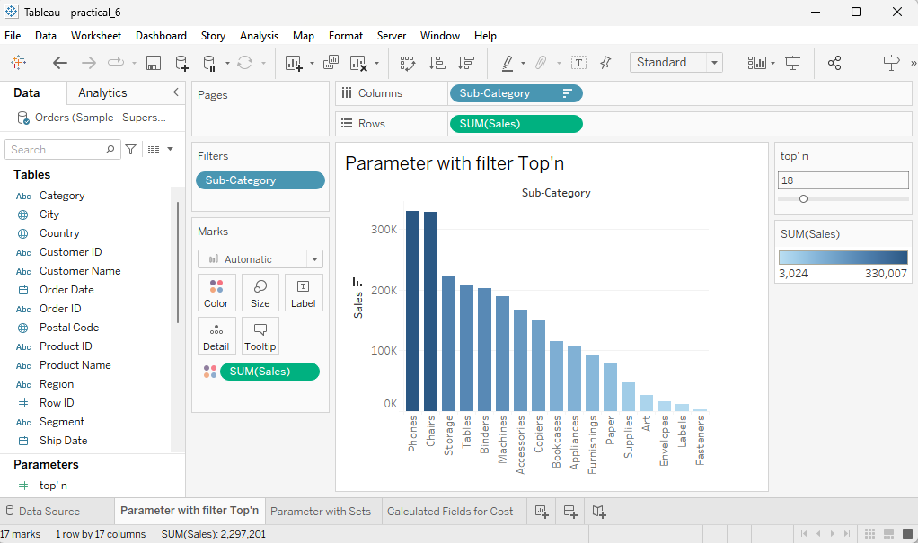

1. **Parameter with Sets**

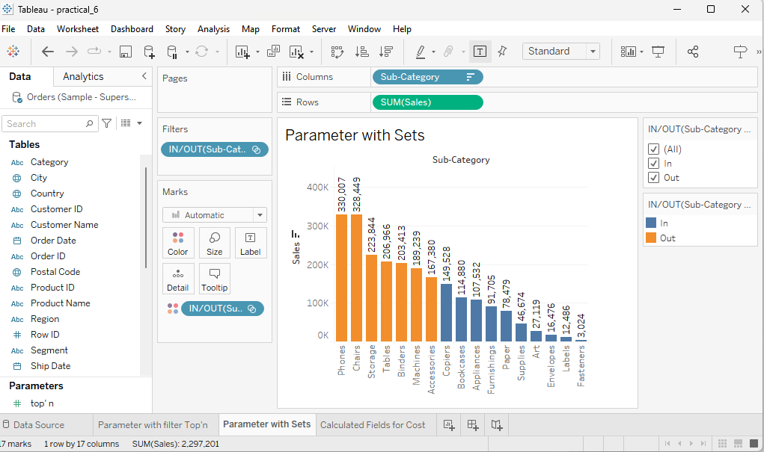

1. **Calculated Fields**

